https://www.figma.com/proto/tUUUtYOWl9vbkKCdYh0SJy/Tech-Support-and-Claims?node-id=7248-16924&viewport=-5152%2C-3904%2C0.8&t=4ngHcbyNIdiXIqHl-1&scaling=scale-down&content-scaling=fixed&starting-point-node-id=7248%3A16924&page-id=1996%3A26552
Legal Review & Feedback 9/21/2026
Screen 1:
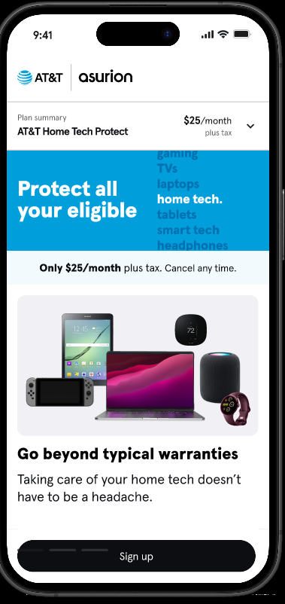

Screen 1, Swipe Right 1:
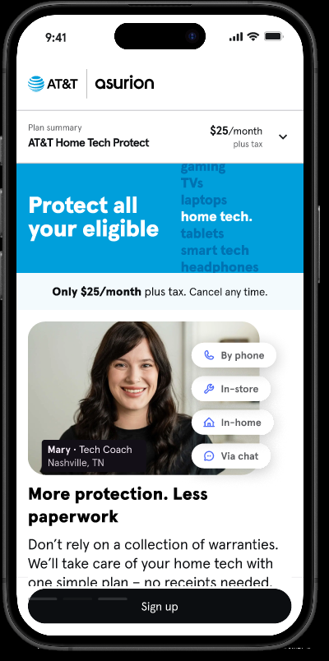

Screen 1, Swipe Right 2:
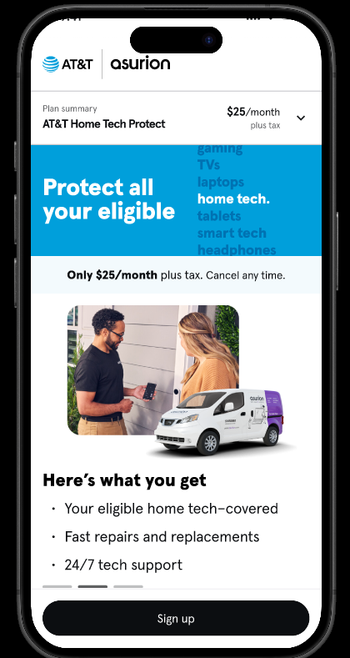

From Screen 1, Clicking "Sign Up” button opens Screen 2:
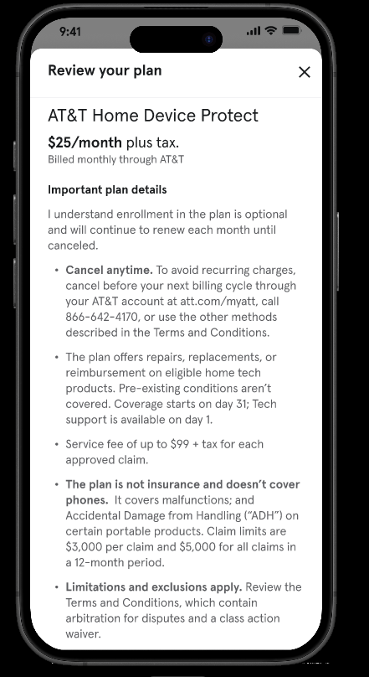

Screen 2, Fully scrolled down:
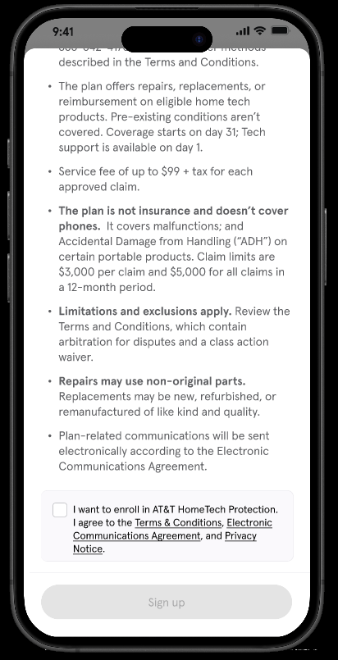
(Links to both Terms, ECA, and Privacy Notice not functional in prototype

Screen 2, Checkbox clicked, enables Sign Up button:
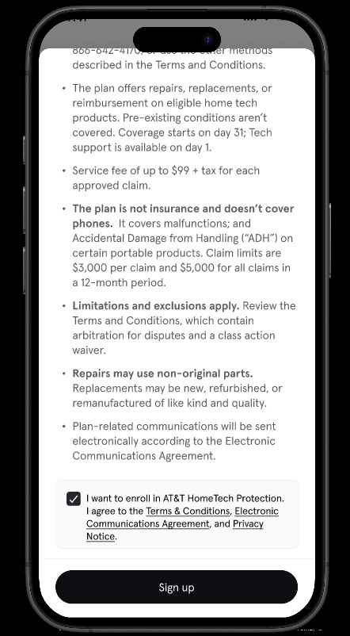

From Screen 2, Sign Up button clicked, Opens Screen 3:


